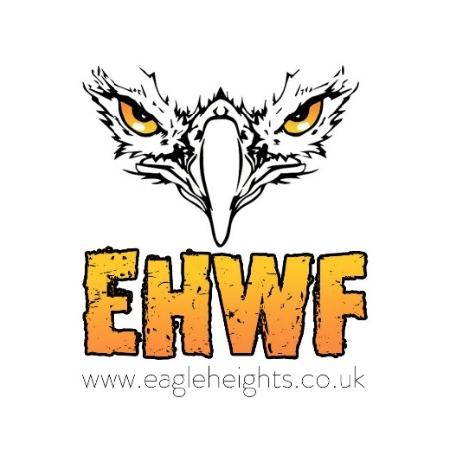

ENVIRONMENTAL POLICY
Here at EHWF we recognise the large demand for natural resources and the pressure this puts on our ecosystem. This is a very serious issue and one which we do not take lightly. We strive to live in balance with nature. Our Environmental Policy is designed to improve our performance in all areas and educate our staff and visitors regarding their impact on the environment.

We are fully committed to improving the environment in which we all live. In particular:

- We spread the environmental message during all our public demonstrations and with signage.
- We only use environmentally friendly products for cleaning purposes both with our animals and in our Tearooms, Shop and Toilets.
- Staff in all areas of EHWF are made aware of our Environmental Policy and strive to carry this policy out to the maximum of their ability.
- We reduce our water usage by collecting rain water to use for watering our plants etc.
- We reduce the amount of waste we produce by recycling and re-using where possible. All cardboard, plastic, cans and paper are recycled.
- New appliances are only purchased if energy efficient.
- The Tea and Coffee served in our Tearoom is certified by the Rainforest Alliance.
- We use Fair Trade and/or Rainforest Alliance certified products for the majority of our products in the Tearoom.
- We only use paper straws.
- We limit all use of containers and packaging for food items.
- We do not use plastic cutlery.
- All cleaning materials used around EHWF are environmentally friendly.

Our Environmental Development Plan is as follows:-

To turn to ‘Green’ roofs. We have started turning some of the enclosure roofs ‘green’ and would like to continue with this, they serve several purposes, absorb rainwater, provide insulation and create a habitat for Wildlife and help lower air temperatures. This will improve and reduce energy consumption. Green roofs also create a natural habitat for insects, birds, bees and butterflies.

To install solar power in as many areas as possible.

To implement more signage regarding environmental matters.

To have regular reviews and improve on all areas that we can where possible.

Lullingstone Lane, Eynsford, Kent, DA4 0JB
office@eagleheights.co.uk www.eagleheights.co.uk

